Third Normal Form (3NF)
In this phase of normalisation, we aim to remove redundant data. This is done by reviewing the design to see that each field can be determined only by the key, and by no other column.
If we include fields in a table that do not have this direct dependency, we will find that we have repeating data in the database, which almost certainly means we have data redundancy.
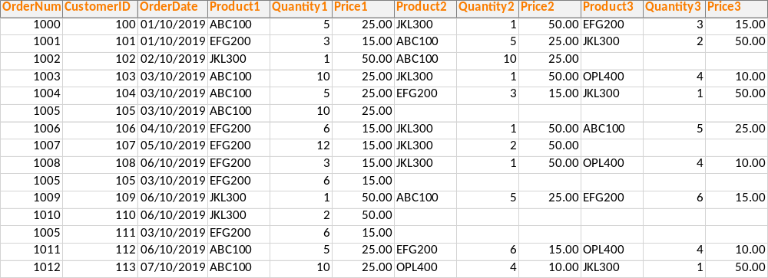
In this example, the price details are not directly dependent on the Primary Key. This is a transitive dependency or an indirect relationship between this attribute and the primary key. It results in the Price data being repeated, i.e. this design contains redundant data.
This is generally resolved by creating another table, and splitting the data into two entities where the relationships are all direct.
Once transitive dependencies have been addressed, we have achieved Third Normal Form.

**Exercise
Suggest a design that would resolve the transitive dependency in the above table and show how the resulting tables would look in an Entity Relationship Diagram.

Un-normalised data
There is still a place for un-normalised data, but it cannot be used in the Relational Model. In any situation where you need to allow multiple items in an attribute, an un-normalised structure would be beneficial. If you ask people for feedback on a form, and allow them to enter free text items, you might want to capture this in an un-normalised table.
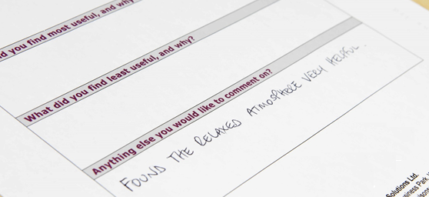

Data Dictionary
Now that you have a normalised database design, there is one more useful step to carry out before you could create your tables in a relational database management system.
For each entity in your Entity Relationship Diagram, you have identified several attributes. In order to ensure you have thought your design through completely, you should create a data dictionary. For each Entity, consider the name you will give its database table. Then for each table, create a data dictionary defining the properties of each field, one for each attribute.
Database | Sales Orders
Entity name | Product
Description | Details to be held for each item in product inventory
Key | Attribute | Data type | Constraints/comments
Primary | ProductID | Long Integer | Required field
 | ProductDescription | String
 | UnitPrice | Currency | Selling price
 | StockLevel | Long Integer
It is helpful to state clearly the purpose of a field, and particularly any limitations on the values it should contain. This is known as the domain of an attribute : the range or set of values that it can should be allowed to hold. This information is needed when creating tables, in order to implement these rules.
Remember that where you have identified a relationship between 2 tables, you need to include the appropriate foreign keys to make the link possible, for example, the CustomerID must be included in the Order table so that we can create a link from the Primary Key of the Customer table to the Foreign Key in the Order table.

Summary
The stages we have identified in the design process for a database are:

Completing database design from an ERD
From the work you have done already you can probably see that it is worth the effort to design a database thoroughly before you commit to creating it. Otherwise you will populate it with data, only to find that the structure does not allow you to do what you need to do, and you have to start again.
A design that has achieved Third Normal Form is ready to be implemented as a database using a relational database management system.
You can show the complete design as a Relational Database Model (logical data model) showing the relationships with their cardinality, the tables with all their attributes and the primary keys which give the unique identifiers:

